**Risk Analysis Report for Company XYZ**

Tricia Lang

Southern New Hampshire University

DAT 610: Operational and Risk Management

Prof. Camac

October 23, 2022

**Operational Risk Management Proposal**

**Organizational Background and Goals**

Company XYZ is a property and casualty insurer. They have been experiencing greater than expected operational losses recently, which have been traced to a primary source of fraudulent automobile personal injury claims. They would like to implement an operational risk management program to reduce the losses due to fraudulent claims.

The company has a goal of utilizing data analytics to identify potentially fraudulent claims and rank them on the likelihood of actually being fraudulent. The company also would like to have the risk management system expand to beyond just investigating fraudulent claims and to include operational risk for the entire organization. All of the risk programs would be reporting to the chief risk officer.

**Established Programs, Policies, Strategies, and Practices**

Company XYZ currently has a special investigations unit (SIU) that investigates suspected fraud. This unit is understaffed and ill-equipped to investigate the high volume of claims that are identified as being potentially fraudulent. The company also does not employ data analytics to the extent possible to identify which claims are more likely to be fraudulent, possibly leading to a larger pool of claims without the ability to prioritize the ones of highest likelihood to be fraudulent.

Currently, these strategies are insufficient to handle the volume of potentially fraudulent claims, leading to greater organizational losses than expected. The SIU for Company XYZ is identified as meeting industry standards so is performing adequately but not efficiently. While identifying understaffing as the primary issue, the volume of claims and prioritization of claims also would benefit from calibration to a more efficient use of staffing.

**Recommended Techniques and Practices**

Improving the risk management of Company XYZ would include building a comprehensive operational risk framework such as that outlined by Girling (2013, pp. 33-38), which includes loss data collection, risk and control self-assessment, scenario analysis, and key risk indicators. The four data building blocks that will be necessary are loss data collection, internal loss data, external loss data, and risk and control self-assessment. This will be managed through data governance headed by the company’s chief risk officer.

The data that is collected will be analyzed and modeled through predictive analytics in R. This will allow for the better identification of higher risk cases and risk factors in the claims submitted to Company XYZ. In creating this model, the higher priority cases can be addressed with those claims that are less likely to be fraudulent not taking up company resources to investigate further.

**Support for Enhancement of Risk Assessment Potential**

Research by Sánchez-Aguayo et al. (2022) evaluated fraud-related keywords to attempt to accurately predict fraud. The results showed that fraud detection utilizing random forest and gradient boosting decision tree modeling were most accurate in predicting fraud, with a mean predictive accuracy of 0.81. Even the less accurate models in this study had a mean predictive accuracy of 0.70, which is an improvement over uninformed decision making as is currently done by Company XYZ, which is expected to have a predictive accuracy of approximately 0.50.

Company XYZ would benefit from improved management of their risk assessment for multiple reasons. Reducing the losses to fraudulent claims, more efficiently using company resources, and improving the products available to the consumers as loss reduction will reduce premiums are just some of the effects of having a risk management plan. Additionally, as this plan will expand beyond fraudulent claims, the security of the company will be improved and allow for a more efficient company performance overall.

**Enterprise Risk Management Tools**

**Tool Recommendations**

Enterprise Risk Management (ERM) tools make the management of risk easier for the company by streamlining the management of risk information. Some tools focus on one area of risk while others cover all seven of the Basel categories of risk (Girling, 2013). What brings Company XYZ to assess for possible risk management solutions is the increase in fraudulent claims, which can be assisted by ERM tools. As noted by Bongiovanni, et al (2021), insurers are looking for more than just risk monitoring and a more proactive approach with a greater understanding of risk. The tool that would be appropriate for Company XYZ would be able to provide this.

Some of the different tools available are pre-packaged by large companies with the possibility of tailoring features to the specific company. Oracle is one company who provides a comprehensive ERM tool that can address all risk management needs of a company. In addition to the security and risk monitoring, there is a feature of advanced transaction analysis that allows for identification of potential areas of risk (Oracle, 2021). As fraudulent claims are the primary area driving Company XYZ to seek assistance at this time, this feature would be very beneficial. A drawback to this package may be the cost. An assessment of the Return on Investment (ROI) would need to occur, though this is a tool that would help Company XYZ achieve their goals.

MetricStream is another company with an ERM tool. A SaaS-based tool, it has the ability to provide analytical insights into the different areas of risk (MetricStream, 2022). The risk categories this product addresses are internal and external fraud, business practices, and process management. The predictive analyses from the data are presented in straight-forward, easy to understand visualizations, which can quickly identify risks associated with fraudulent claims. As a product that is scalable to the size of the company, this may be the a cost-effective and capable program that fits the needs of Company XYZ.

A third option for an ERM tool is by the company Quantivate. A smaller company that specializes in Governance, Risk, and Compliance (GRC) and works with financial institutions as well as other businesses, this tool would be scalable to meet the needs of a company the size of Company XYZ (Quantivate, 2022). This SaaS-based tool is able to identify areas of risk and aggregates this information for the company to decide on actions to be taken. With focuses on past and mitigating risks for future losses, the areas of risk this tool focuses on are internal and external fraud, business practices, and process management. As a tool that can be used on devices running Windows, Android, or iOS, the visualizations are portable and not limited by the technology of the user.

Three ERM tools that could be very helpful for Company XYZ with reducing the risk from fraudulent claims are from Oracle, MetricStream, and Quantivate. The tools come in at different price points, which would need to be investigated further for whether the additional cost and features are worth the ROI. All three are able to provide visualizations and make predictive analyses of the risks using reliable tools, assisting in the communication of these results to all stakeholders. These three would be good options for Company XYZ.

**Industry-Standard Visualization Techniques**

Visualization of data is one of the most effective ways to communicate the meaning of the data. In order to create a visualization that is representative of the data, the data must be understood and presented in a way that the audience can understand (Yau, 2013). In general, visualizations of data rely on the presentation of visual cues, such as positioning, directionality, colors, angles, and size. For risk management visualizations, the same principles apply.

From a project management perspective, identifying risk can be done using a Visual Ishikawa Risk Technique (VIRT), which assists in the identification of potential risk areas within a project (Jen, 2010). The resulting “fish-bone” visual outlines potential business risks. This tool is useful in the creation of a new product or ongoing monitoring of risk within a project, but less useful and more restrictive than other methods to visualize risk.

Preliminary guidelines put forth by Eppler and Aeschimann (2009) identify six areas for effective communication of risk through visualization. The first is the timing of the visualization. In presenting data visually, the authors note that visualizations can solidify a perception of risk, and due to this influence the leading information should be more neutral unless there is a need to press an imminent risk. An example of this would be presenting that 75% of insurance fraud cases are related to incidents with minor cost. What may get lost is that the 5% of fraudulent claims may comprise more than 75% of the cost of claims. By presenting the information around the fiscally minor cases the attention of the audience will be drawn to that information and lose the bigger picture.

A second guideline proposed by the authors is to present the information in an unambiguous and audience-appropriate way. If the intended audience is a person without a need for statistical knowledge, the numbers may not be the focus of the visualization. Instead, color-coding or using size and volume of data points to reflect the importance may be more effective. For an audience that is invested in the calculations, the numbers may be more appropriate and should not be lost in communicating things in a way that may be perceived as superfluous or fancy.

As was described in further detail by Yau (2013), the guidelines from Eppler and Aeschimann (2009) underscore the need to follow the same principles of visualization with the use of size, location, and shape of data points. As well, anything that is measuring time is read from left to right and should include a title that is informative. In the example of fraudulent car insurance claims, distinct types of claims may be represented by different shapes, and if tracking number of claims across a timeline, the earlier dates would be on the left and along a continuum to the right. Data that stands out may be enlarged to draw the focus to that point.

Earlier discussion about targeting an audience noted that some visualizations can be considered superfluous. Another of the guidelines by Eppler and Aeschimann (2009) advises to avoid effects or decorations that do not add benefit to the interpretation of the visualization. Specifically, keeping fonts similar and professional will not detract from the visualization, rather than using shading or other effects.

Guidelines also note to think of visualizations as being more fluid and inviting of changes or enhancements to meet the needs of the audience. This can include making the visualizations interactive or updating in real time. This also ties into the final guideline from the authors, to incorporate feedback from someone who is not actively involved with the data to test whether the visualization is easy to comprehend. Overall, these guidelines can be incorporated in visualizations of risk used by Company XYZ. Once the data is understood and the audience needs are known, the visualizations can begin to take form.

**Visualization Proposal**

Visualizations described by Eppler and Aeschimann (2009) outline the ways visualizations can be useful to particular audiences and for specific information. Quantitative dashboards are effective in communicating risk. An interactive dashboard would be a useful tool for Company XYZ. An example of this can be seen in Figure 1 from MetricStream (n.d.). Each of the individual charts have the option to dive deeper into the data by area of risk, degree of risk, and date range. This provides the opportunity to have the information at a glance as well as greater detail if needed.

**Figure 1**

***Sample Dashboard from MetricStream***

In order to identify what the higher risk claims are, where the greatest monetary loss is, and identify trends over time. Using a tool that has a drill-through ability can provide more detailed information for those who need to know would be particularly useful to multiple audiences. Tracking the number of incidents of fraudulent claims, the cost of those claims, and the times of year that certain claims may occur more frequently than others are several visualizations that can be incorporated in the dashboard.

Data maps of locations of claims can also be included in this dashboard. This may be helpful for locating hotspots for specific types of fraudulent claims. An example of this would be if someone indicated they struck a deer in a place that is not known for collisions with deer, such as a downtown area, it may flag as a higher risk claim. Areas where there is low traffic and there may not be an opportunity for excessive speed may also be a less likely location for an accident that results in an injury.

Cherolis (2022) discusses the use of interactive heat maps to gain further insight into areas of higher risk from the perspective of identifying where safety measures may be of most benefit. One of the heat maps created by Cherolis can be seen in Figure 2, where the locations with the highest number of injuries or fatalities are seen with the darkest red colors and transitions to blue and white for the lowest number of accidents with a resulting injury or fatality. This could also be used by Company XYZ in identifying whether a low-risk area is a location of a high-priced claim, which may raise suspicion for fraud.

**Figure 2**

***Example of Heat Map for Traffic Accidents***

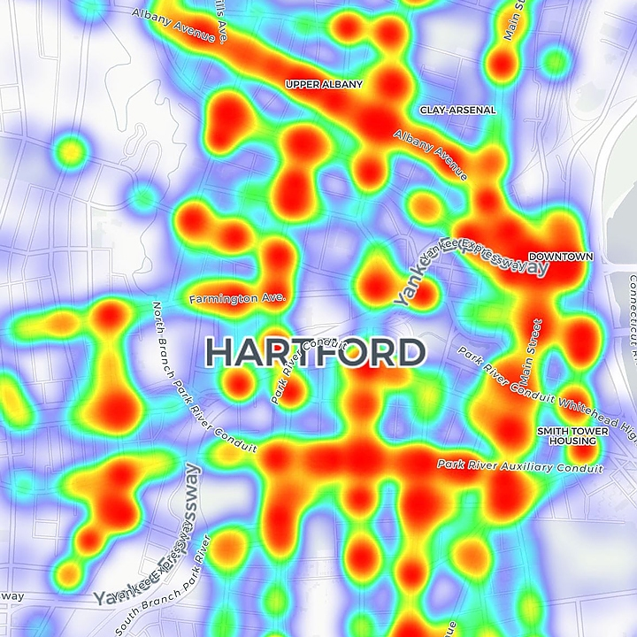

Other visualizations within the dashboard can plot the trends against exceptions (DAMA International, 2017), to highlight expected claims or amounts against what claims are received. This can highlight claims to investigate more closely. This can also be a real-time visualization that adds to the trends with all new data points as well as comparing the new claims. As seen in Figure 3 from Marru (2016), this is an easy visualization to interpret quickly. There are also opportunities to explore the data more closely, as seen in the circled area of the figure highlights the place in this graphic to obtain more information. Examining the peaks or valleys in the trend or times when the gaps have been greatest to get a better idea of what the circumstances occurring at that time that influenced the outcome is made easy.

**Figure 3**

***Trend vs. Exception Plot***

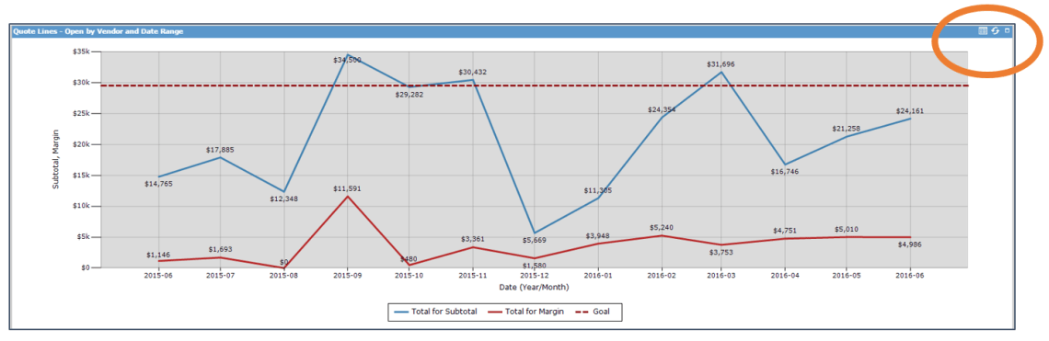

*Note.* Circled area indicates where more detailed information can be accessed within the visualization.

A risk dashboard would be an effective way to communicate risk. The varying levels of detail will meet the needs of the different stakeholders, from claim adjusters to managers and any others. By following the guidelines and general principles of visualization it is a tool that can meet the needs of Company XYZ.

**Summary**

Company XYZ has requested an evaluation of their current risk management system and identify areas for potential improvement. The improvements the company wishes to make will expand through the organization and apply to all areas of the business. Recommendations include focusing on loss data collection, internal loss data, external loss data, and risk and control self-assessment, which are the four building blocks in the operational risk framework consisting of areas such as loss data collection, risk and control self-assessment, scenario analysis, and key risk indicators (Girling, 2013). Building a risk management model with an empirically sound foundation will help Company XYZ reduce risk and improve company functioning overall.

Risk models can be built using different packages in R that will assist in predicting which claims may be higher risk. This modeling can also be applied to other areas within the company, such as risk of defaulting on premium payments or risk of filing multiple claims. Enterprise Risk Management tools can assist in organizing this information and providing as broad or detailed of information as various departments within the company need.

Of the tools available, MetricStream is suggested due to the ease of use and the ability to access information easily. Visualizations are an important part of obtaining the information from predictive models. MetricStream is a tool that is able to create individualized dashboards with the depth of detail that may be desired with drill through options within the visualizations. As well, there are a myriad of types of visualizations based on which departments within Company XYZ need what type of information.

Overall, an Enterprise Risk Management system would assist Company XYZ in being more efficient, effective, and reliable. Providing useful tools and analyses to make the most of their greatest asset, data, will reduce cost and risk of fraud. Across the company an ERM system will increase the security and safety of the organization and employees.

**References**

Bongiovanni, C., Pancaldi, L., Stegemann, U., & Taglioni, G. (2021, June 22). *Transforming enterprise risk management for value in the insurance industry*. McKinsey & Company. Retrieved September 11, 2022, from https://www.mckinsey.com/business-functions/risk-and-resilience/our-insights/transforming-enterprise-risk-management-for-value-in-the-insurance-industry

Cherolis, A. (2022, January 2). *ANALYSIS | What Can We Learn From an Interactive Crash Map?* CT News Junkie. Retrieved October 21, 2022, from https://ctnewsjunkie.com/2020/09/02/20200902_analysis_what_can_we_learn_from_an_interactive_crash_map/

DAMA International. (2017, July 1). *DAMA-DMBOK: Data Management Body of Knowledge: 2nd Edition* (Second). Technics Publications.

Eppler, M. J., & Aeschimann, M. (2009, April). A systematic framework for risk visualization in risk management and communication. *Risk Management*, *11*(2), 67–89. Retrieved September 24, 2022, from https://www.researchgate.net/publication/228533068_A_systematic_framework_for_risk_visualization_in_risk_management_and_communication

Girling, P. (2013). *Operational Risk Management: A Complete Guide to a Successful Operational Risk Framework* (1st ed.) [E-book]. Wiley.

Jen, R. (2010). Visualizing risk management—a new approach. Paper presented at PMI® Global Congress 2010—North America, Washington, DC. Newtown Square, PA: Project Management Institute.

Marru, S. (2016, June 30). *Business Intelligence with CRM: Trend vs. Exception Reporting – Are You Spending Your Time Wisely?* Selltis CRM. Retrieved October 21, 2022, from http://selltis.com/business-intelligence-with-crm-trend-vs-exception-reporting-are-you-spending-your-time-wisely/

MetricStream. (n.d.). *Enterprise and Operational Risk Management*. Metricstream. Retrieved October 21, 2022, from https://www.metricstream.com/products/enterprise-and-operational-risk.htm

MetricStream. (2022). *Enterprise and Operational Risk Management*. Metricstream. Retrieved September 11, 2022, from https://www.metricstream.com/products/enterprise-and-operational-risk.htm

Oracle. (2021). *Oracle Fusion Cloud Risk Management and Compliance*. Oracle.com. Retrieved September 11, 2022, from https://www.oracle.com/a/ocom/docs/applications/erp/oracle-risk-management-cloud-ds.pdf

Quantivate. (2022, April 28). *Enterprise Risk Management (ERM) Solution*. Retrieved September 11, 2022, from https://quantivate.com/enterprise-risk-management-solution/

Sánchez-Aguayo, M., Urquiza-Aguiar, L., & Estrada-Jiménez, J. (2022). Predictive Fraud Analysis Applying the Fraud Triangle Theory through Data Mining Techniques. *Applied Sciences*, *12*(7), 3382. https://doi.org/10.3390/app12073382

Technology Advice. (2022, September 11). *TechnologyAdvice Buyer’s Guide to ERM Software*. TechnologyAdvice.com. Retrieved September 11, 2022, from https://technologyadvice.com/erm-software/

Yau, N. (2013, March 1). *Data Points: Visualization That Means Something*. Wiley.